Final Project

The program is run just like any other, but needs to be run with 2 other files within the same directory (both of which are included in the submission):

* system.mac
* final.dat

The purpose of this project is to allow the user to select a single-digit number 1-9 to be multiplied by another single-digit number 1-9. The products are displayed to the console, see image below. The user is prompted to enter a single-digit number forever until they enter ’q’.

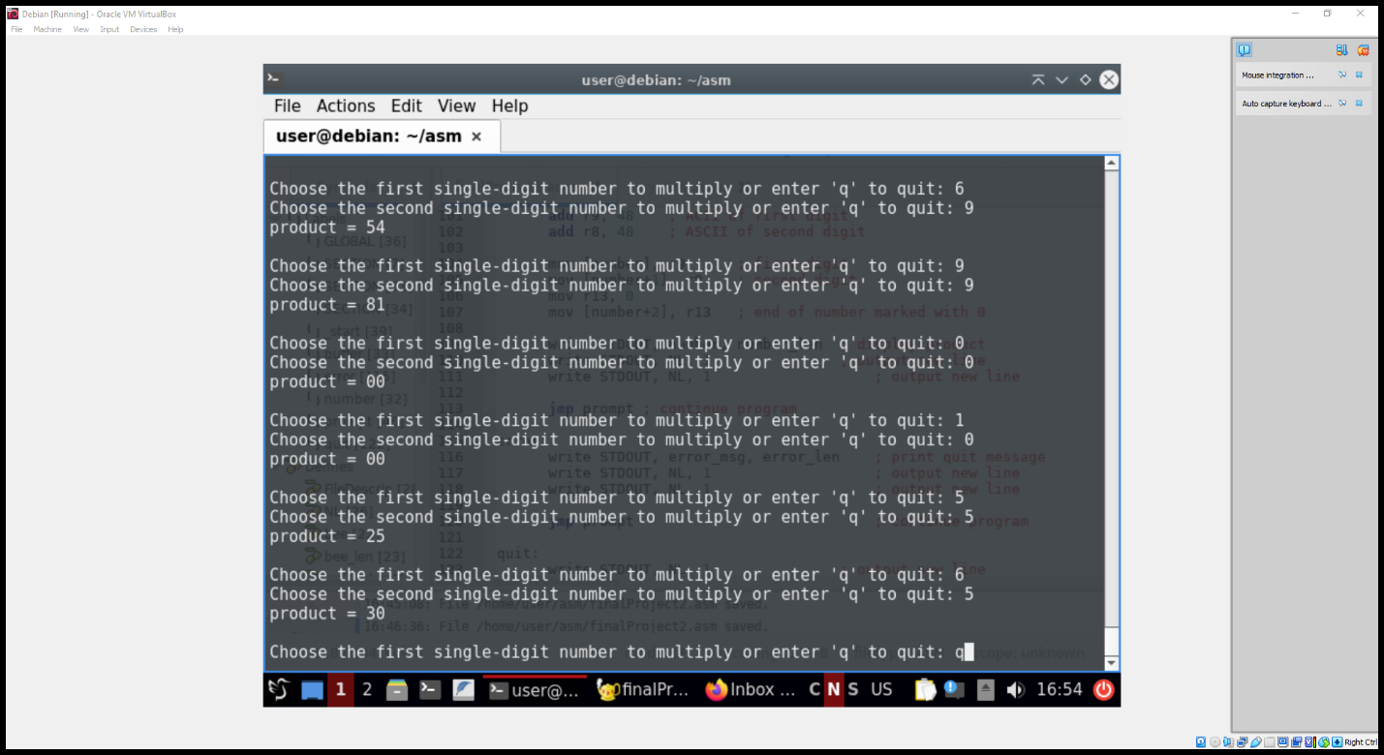

If the user enters something outside the range of 0-9, an error message will display and the option to enter a valid character comes again.  
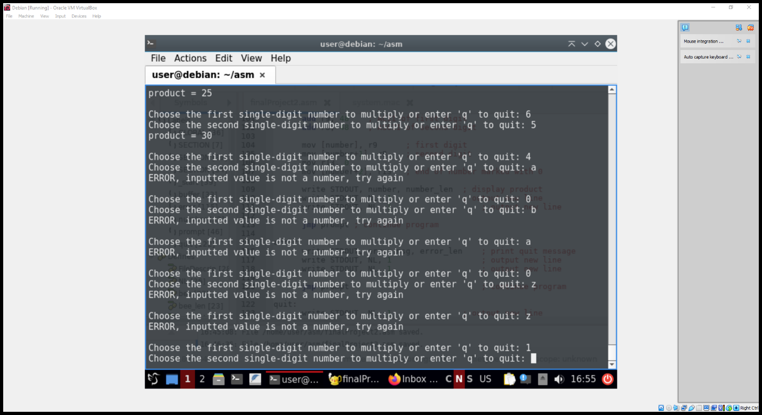

And when the user finally enters q, the program will begin the process of exiting, but not without printing the entire Bee Movie script first. I thought it would be funny to add this part.  
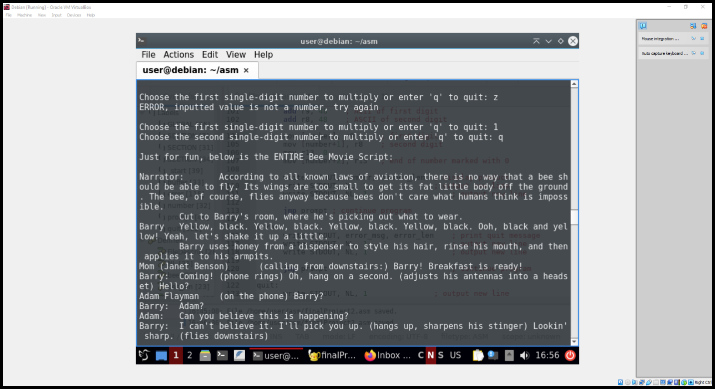

Right after the Bee Movie script, is a message stating that the program is exiting. (Such a good movie, even the script is fun to read.)  
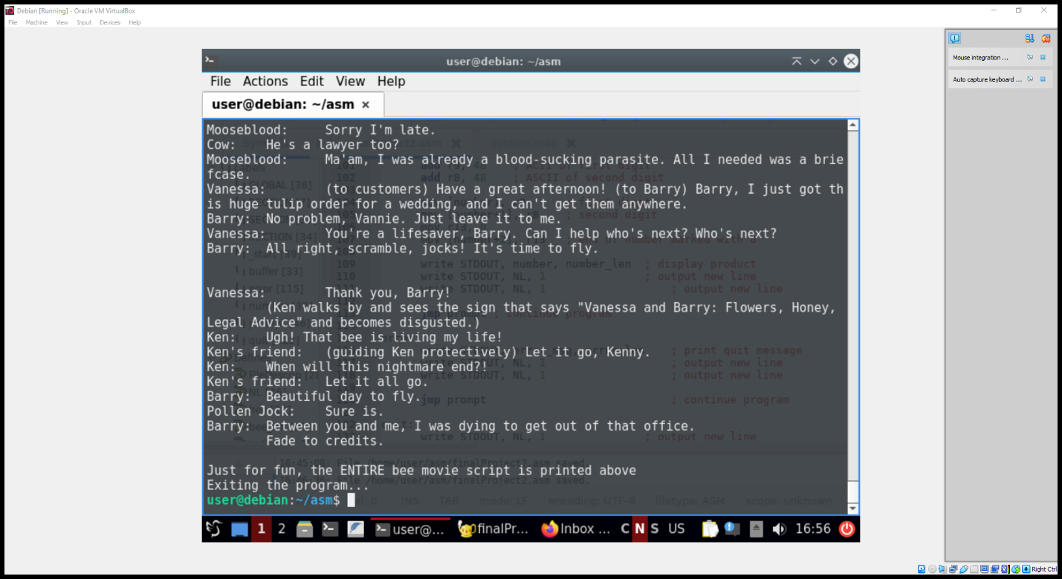

The lessons learned include combining chunks of code into macros, dividing to get quotient and remainder, converting to a from ASCII, getting input from the user, and displaying to the user. Each of these lessons are difficult with their own challenges.

The challenges I faced were trying to give the user the ability to select the second number so that it does not need to be 6 every time. This was such a hard problem that this part of the project was almost scrapped. Using gdb, I could not figure out what was wrong and only got the code to work when I used r12 instead of r11 for something specific as the tutor suggested. It makes so sense for why that was the problem and neither the tutor nor I could figure out why changing the register fixed it.